Details on Young Living’s Testing of Cinnamon Bark
- Young Living’s Research and Development team reproduced the GC-MS analysis on the Cinnamon Bark essential oil lot #15B10032 specified in the Facebook post in question.
- In addition, Young Living tested two other lots.
- Each lot was tested in triplicate.
- Consistent with pharmaceutical Good Manufacturing Practices (GMPs), solvent blanks were run before and after each test sample to prevent contamination between samples. In addition to the basic analysis described in the Facebook post, Young Living employed a number of techniques, including full-scan monitoring, retention index, retention time, and selected ion monitoring.
- All chromatograms from each of the three lots were virtually identical, with no evidence of synthetic materials in any of the samples. A chromatogram from the lot in question is shown below.
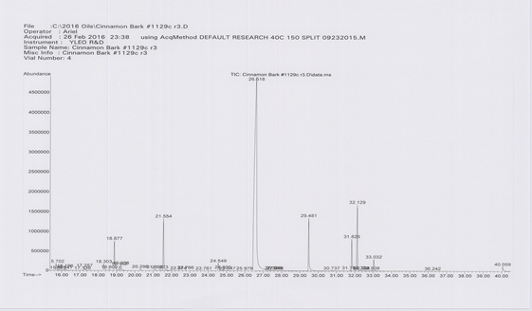

- Figure 1: Chromatogram (Total Ion Current) of Cinnamon Bark lot #15B10032
- A claim was made on Facebook that this particular lot was contaminated with synthetic linalool and synthetic cinnamic aldehyde. In the Facebook post, the competitor claimed that α-linalool, plinol, 2-propenyl phenol, and phenylpentadienal are chemical markers for synthetic ingredients. The competitor also claimed that BHT (a foreign synthetic compound) was found in the sample.
Our testing did not detect the presence of any of the compounds the Facebook competitor claimed to be markers of synthetic material, with the one exception of plinol, which was detected by both the competitor and Young Living. However, plinol is a naturally occurring terpenoid, as reported in peer reviewed scientific literature.
Additionally, we had an independent lab based in France test the same sample. The results from that lab’s GC-MS analysis confirmed our own analyses.
As the world leader in essential oils, Young Living invests significantly in quality assurance. Our Research and Development team has more than 180 years of combined experience in analytical chemistry. We are committed to quality and purity and to providing the best products possible to our customers.

Rocha et al., Comprehensive two-dimensional gas chromatography with time of flight mass spectrometry of monoterpenoids as a powerful tool for grape origin traceability, J. Chromatography A, 1162 (2007) 292-299.

